Angular Components:

**Components** are the most basic UI building block of an **Angular** app. An **Angular** app contains a tree of **Angular components**.

We may have one or more components in every Angular projects, in large applications we have tens of components.

**Component encapsulate the data, logic, and HTML for a view - means everything user sees on screen.**

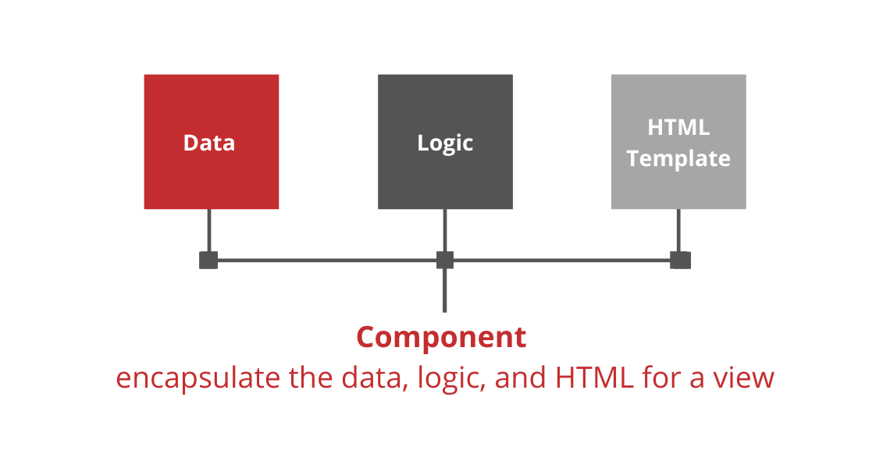

We can have One single Component {} for Navigation bar, Side bar and Content area.

Or we can have separate component for each area — Nav bar component {}, Side bar component {} and Content area component {} — that is Smaller, Maintainable and Reusable Components.

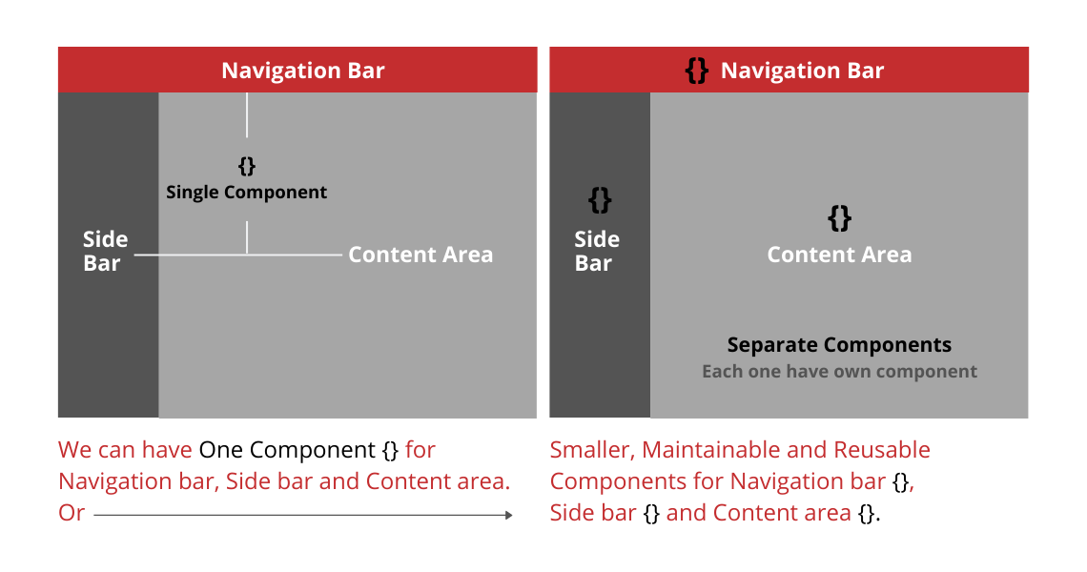

Even we can divide Content Area in many smaller Components. Look below👇 Content area have many components.

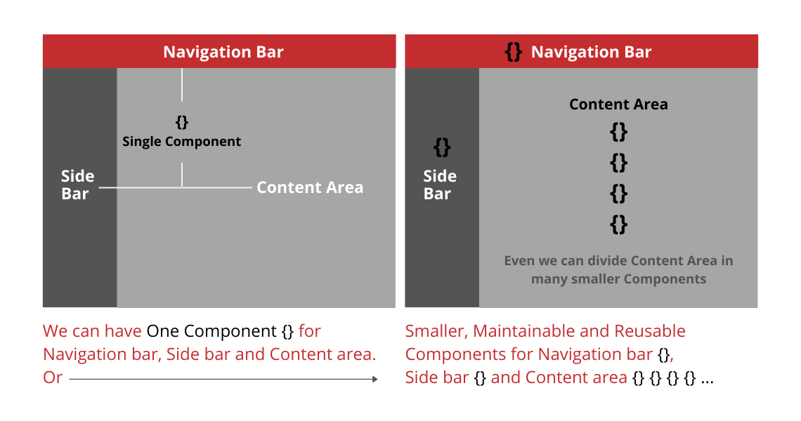

*We can divide our application in many components to reuse them within the app or other app*. In every Angular application we have at least one component which is App Component or Route Component. Look below the tree of components starting from app component.

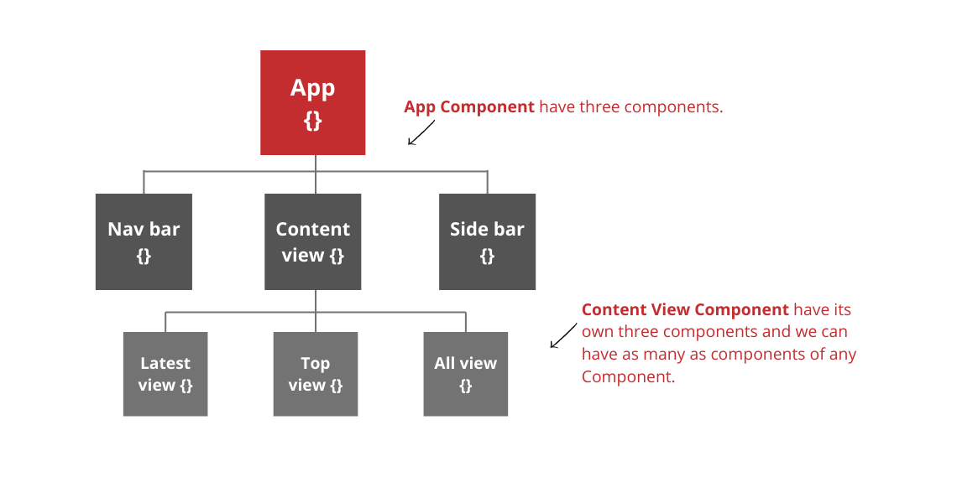

The below are the componets related questions

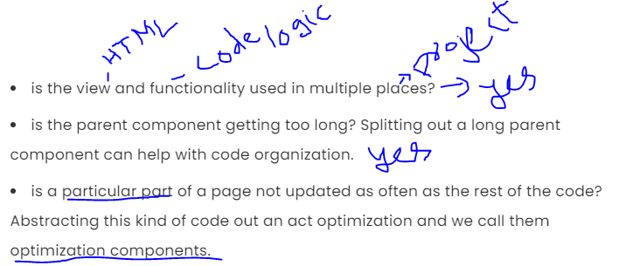

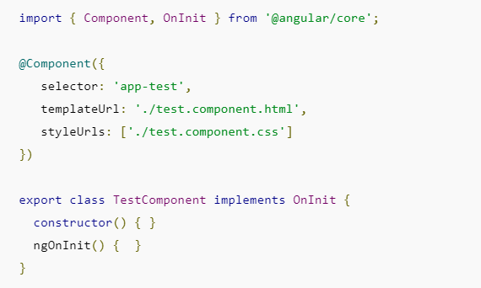

This lets you use the @Component decorator, which essentially tells Angular the meta-data required to make a component possible.

We keep them these in declarations if you want to use them in the current module.

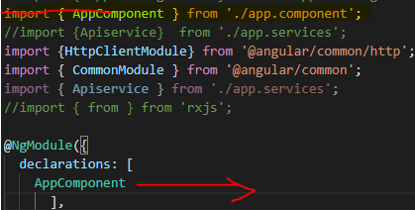

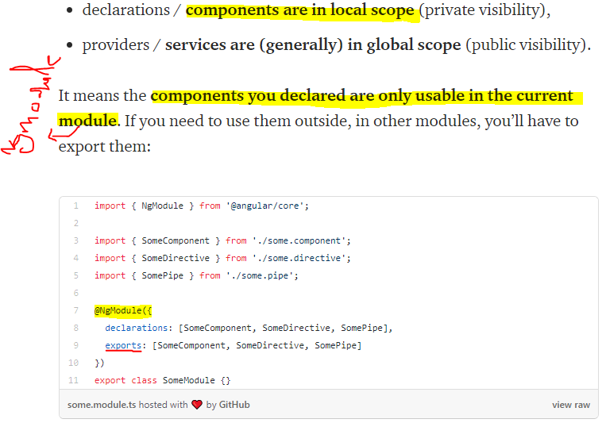

**Component to component services:**

*1 method) Sharing the data from parent to child by using @input () decorator:*

|  |  |
| --- | --- |
| **App.component.ts: Parent**  import {Component} from '@angular/core';  @Component ({  selector: 'app-root',  template URL: './app.component.html',  style URLs: ['./app.component.css']  })  export class AppComponent {  public title: any = 'component service-parent';  } | **Appcomponent.html**  <div>  <h1>{{title}}</h1></div>  <child-root [value]="title"> </child-root>  *<!--value is our defined value title came form appcompoent.tsfile-->* |
| **Childcomponet.html**  <h3>child component</h3>  <h1>{{value}}</h1> | **Childcomponet.ts child**  import { Component, Input } from '@angular/core';  @Component({  selector: 'child-root',  templateUrl: './child.component.html',  styleUrls: ['./child.component.css']  })  export class ChildComponent {  //title = 'componentserviceChild';  private name:any="GEETHA-childcomponent";  @Input()  public value:any;  } |

Output:

